Section I: Scenario Demographics

Scenario Title: | Simple MVC with Tension PTX
Date of Development: | 29/05/2015 (DD/MM/YYYY)
Target Learning Group: | Juniors (PGY 1 – 2) Seniors (PGY ≥ 3) All Groups

Section II: Scenario Developers

Scenario Developer(s): | Kyla Caners
Affiliations/Institution(s): | McMaster University
Contact E-mail (optional): | kcaners@gmail.com

Section III: Curriculum Integration

Learning Goals & Objectives
Educational Goal: | To expose learners to trauma patients that require multiple concurrent management steps.
CRM Objectives: | Effectively lead a trauma team
Medical Objectives: | - Perform safe primary survey and a proper secondary survey.  - Recognize and decompress a tension pneumothorax.  - Appropriately manage an open fracture in a trauma patient.

Case Summary: Brief Summary of Case Progression and Major Events
A 44 year-old male arrives by EMS to a tertiary care ED where the trauma team has been activated. He was the driver in a single-vehicle MVC. He presents screaming and moaning with a GCS of 13. He has an obvious open fracture of his right forearm. He also has decreased air entry to the right side of his chest. The team will need to recognize the tension pneumothorax as part of their primary survey. They will then need to irrigate and splint the right arm after they have completed their secondary survey. As the secondary survey is being completed, the patient will become hypotensive again. This time, the team will find free fluid in the RUQ.

References
Marx, J. A., Hockberger, R. S., Walls, R. M., & Adams, J. (2013). Rosen's emergency medicine: Concepts and clinical practice. St. Louis: Mosby.

Section IV: Scenario Script

A. Scenario Cast & Realism
Patient: | Computerized Mannequin |  |  |  |  | Realism:  Select most important dimension(s) |  |  | Conceptual
 | Mannequin |  |  |  |  |  |  |  | Physical
 | Standardized Patient |  |  |  |  |  |  |  | Emotional/Experiential
 | Hybrid |  |  |  |  |  |  |  | Other:
 | Task Trainer |  |  |  |  |  |  |  | N/A
Confederates | Brief Description of Role
None.
B. Required Monitors
EKG Leads/Wires |  |  | Temperature Probe |  |  |  | Central Venous Line
NIBP Cuff |  |  | Defibrillator Pads |  |  |  | Capnography
Pulse Oximeter |  |  | Arterial Line |  |  |  | Other:
C. Required Equipment
Gloves |  |  | Nasal Prongs |  |  |  | Scalpel
Stethoscope |  |  | Venturi Mask |  |  |  | Tube Thoracostomy Kit
Defibrillator |  |  | Non-Rebreather Mask |  |  |  | Cricothyroidotomy Kit
IV Bags/Lines |  |  | Bag Valve Mask |  |  |  | Thoracotomy Kit
IV Push Medications |  |  | Laryngoscope |  |  |  | Central Line Kit
PO Tabs |  |  | Video Assisted Laryngoscope |  |  |  | Arterial Line Kit
Blood Products |  |  | ET Tubes |  |  |  | Other: 14G angiocatheter
Intraosseous Set-up |  |  | LMA |  |  |  | Other:
D. Moulage
Open fracture of forearm.

E. Approximate Timing
Set-Up: |  | 6 min |  | Scenario: | 12 min |  |  | Debriefing: |  | 15 min

Section V: Patient Data and Baseline State

A. Clinical Vignette: To Read Aloud at Beginning of Case
EMS arrives with a 44-year-old male to your tertiary care ED. The trauma team has been activated. He was the driver in a single vehicle MVC at highway speed. There was extensive damage to the car. He is currently screaming and moaning.
B. Patient Profile and History
Patient Name: Joel Brown |  |  |  |  |  | Age: 44 |  |  |  |  |  |  |  | Weight: 70kg
Gender: M F |  |  |  |  |  | Code Status: Full
Chief Complaint: MVC
History of Presenting Illness: Single vehicle MVC at highway speed.
Past Medical History: |  | EtOH abuse |  |  |  |  | Medications: |  |  |  |  | None.
Allergies: None.
Social History: Unknown.
Family History: Unknown.
Review of Systems: |  | CNS: |  |  | Not cooperative.
 |  | HEENT: |  |  | Nil.
 |  | CVS: |  |  | Some CP if asked.
 |  | RESP: |  |  | Feels SOB if asked.
 |  | GI: |  |  | Nil.
 |  | GU: |  |  | Nil.
 |  | MSK: |  |  | Screams when move R arm. |  |  |  |  |  |  |  | INT: |  | Nil.
C. Baseline Simulator State and Physical Exam
No Monitor Display |  |  |  | Monitor On, no data displayed |  |  |  |  |  |  | Monitor on Standard Display
HR: 130/min |  |  | BP: 75/35 |  |  |  |  | RR: 26/min |  |  |  |  |  |  | O₂SAT: 94%
Rhythm: Sinus tach |  |  | T: 36.2ºC |  |  |  |  | Glucose: 6.4 mmol/L |  |  |  |  |  |  | GCS: 13 (E4 V4 M5)
General Status: Appears in pain. Agitated.
CNS: | Not obeying commands. Will answers simple yes/no questions. Not oriented.
HEENT: | PERLA, 4mm. No signs HI.
CVS: | Normal S1/S2. No murmurs.
RESP: | No AE to R side.
ABDO: | Soft, NT.
GU: | Nil.
MSK: | Pelvis stable. Open # to R forearm. |  |  |  |  |  |  |  | SKIN: | Nil else.

Scenario States, Modifiers and Triggers
Patient State | Patient Status | Learner Actions, Modifiers & Triggers to Move to Next State
1. Baseline State  Rhythm: Sinus tach  HR: 130/min  BP: 75/35  RR: 26/min  O₂SAT: 94%  T: 36.2ºC | Patient is screaming and moaning, not obeying commands. Answers simple questions. | Learner Actions  - ABC, monitors, iv access x2  - Bolus IVF, call for blood  - Blood work (inc. G&S)  - Needle decompress chest  - ± Chest tube insertion  - Call for CXR/PXR  - Analgesia (fentanyl or ketamine iv)  - Check cap sugar (6.4)  - Administer TXA 1g iv | Modifiers  Changes to patient condition based on learner action  - No needle decompression by 3 minutes BP 60/30, O₂SAT 90%, HR 140  Triggers  For progression to next state  - Needle decompression  2. Stabilization
2. Stabilization  HR 110  BP 95/60 | Patient still moans, responds. But less wild after analgesia. | Learner Actions  - Chest tube insertion  - CXR/PXR  - Complete px exam  - FAST to r/o FF (+ RUQ)  - Td 0.5 ml IM  - Ancef 2g iv ± gentamycin iv  - Irrigate and splint open # | Modifiers  - No lidocaine for chest tube insertion patient screams ++  Triggers  - Chest tube inserted or FAST complete 3. Repeat hypotension  - 8 minutes 3. Repeat hypotension
3. Repeat hypotension  HR 125  BP 75/35 | As above. | Learner Actions  - Re-check air entry  - FAST to r/o FF (+ RUQ)  - Pericardial U/S to r/o tamponade  - Assess chest tube drainage, consider repeat CXR or U/S  - Administer 2u PRBC  - Administer TXA 1g iv (if not yet done)  - Call general surgery | Modifiers  - 1 unit PRBC BP 80/40  - No FAST by 10 min BP 70/30  - No FAST by 11 min BP 65/30  Triggers  - 2 units PRBC and surgery called 4. Resolution  - 12 minutes 4. Resolution
4. Resolution  HR 115  BP 85/45 | As above. | Learner Actions  - Consider intubation for OR  - Call consultants | END CASE GEN SX ARRIVES
Section VI: Scenario Progression

Images (ECGs, CXRs, etc.)
ECG: sinus tachycardia  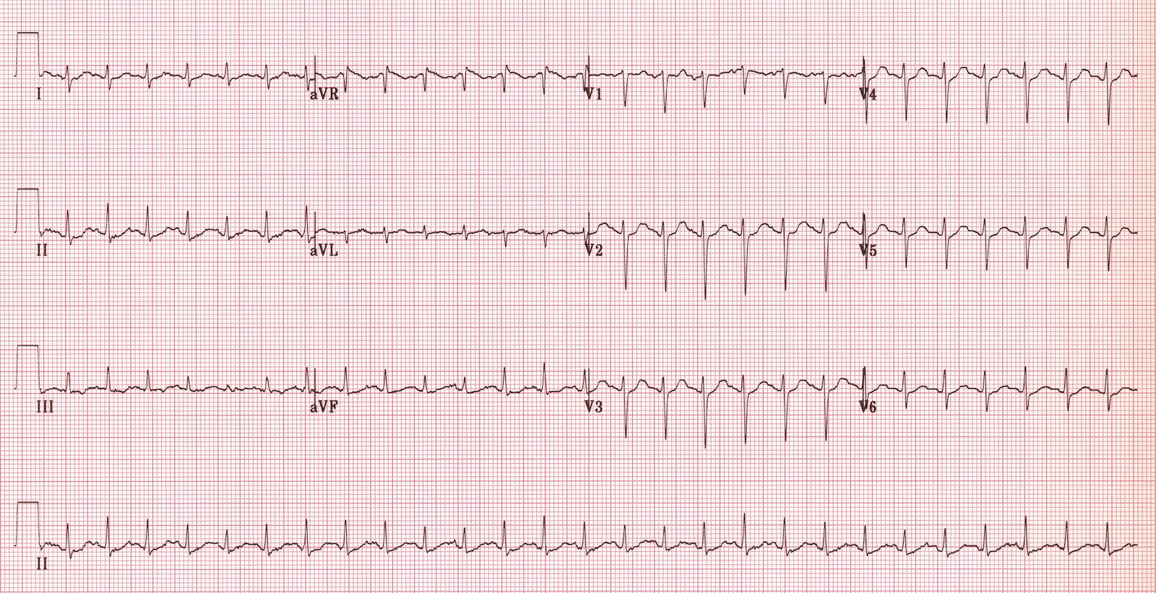  ECG source: https://lifeinthefastlane.com/ecg-library/sinus-tachycardia/ | CXR: prior to needle decompression  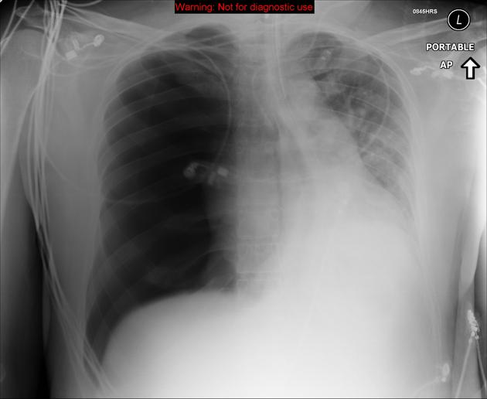  CXR source: https://radiopaedia.org/cases/tension-pneumothorax-9
Pelvic xray: normal  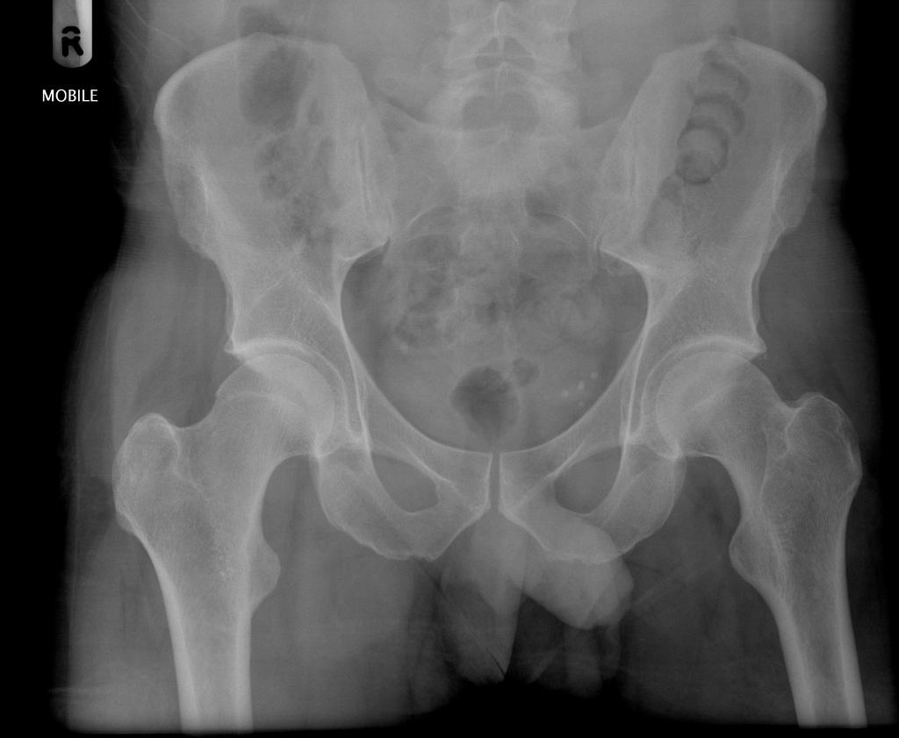  PXR source: http://radiopaedia.org/articles/pelvis-1 | CXR: post chest tube placement  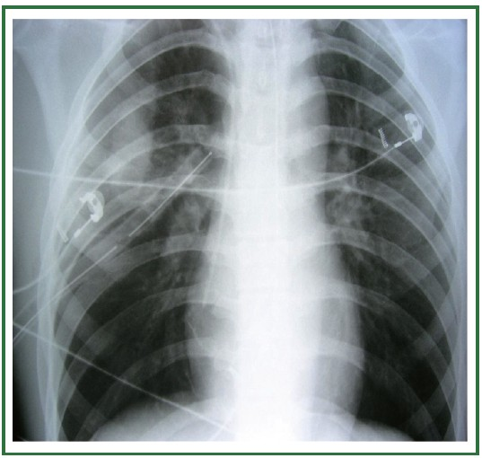  CXR source: http://jtd.amegroups.com/article/view/663/html
Ultrasound Video Files (if applicable)
U/S RUQ showing free fluid
U/S pericardium showing no effusion

Section VII: Supporting Documents, Laboratory Results, & Multimedia

Laboratory Results
None given during scenario.

Section VIII: Debriefing Guide

General Debriefing Plan
Individual | Group |  | With Video | Without Video
Objectives
Educational Goal: |  | To expose learners to trauma patients that require multiple concurrent management steps.
CRM Objectives: |  | Effectively lead a trauma team
Medical Objectives: |  | - Perform safe and thorough primary survey.  - Recognize and decompress a tension pneumothorax.  - Appropriately manage an open fracture in a trauma patient.
Sample Questions for Debriefing
- When did you recognize the tension pneumothorax?
- What is your approach to fluid resuscitation in trauma?
- What approach did the team leader use to organizing the initial management of this trauma? Does ABC (with stops for interventions) work or should we be completing a primary survey and then delegating tasks from there?
- How did the mood of the room feel? Did the team feel and recognize when the patient was worsening?
Key Moments
1) Recognition of PTX
2) Completing secondary survey
3) Repeating primary survey when patient’s BP worsened

